## 單元:Line Bot

1. 開發設定
   1. 申請 Line 開發者帳號

<https://developers.line.biz/zh-hant/>

Line帳號登入

* 1. 新增 Provider & create provider Nma

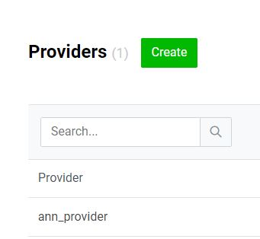

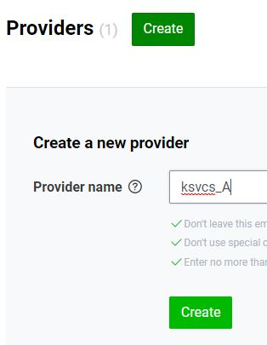

* 1. Create new Channel

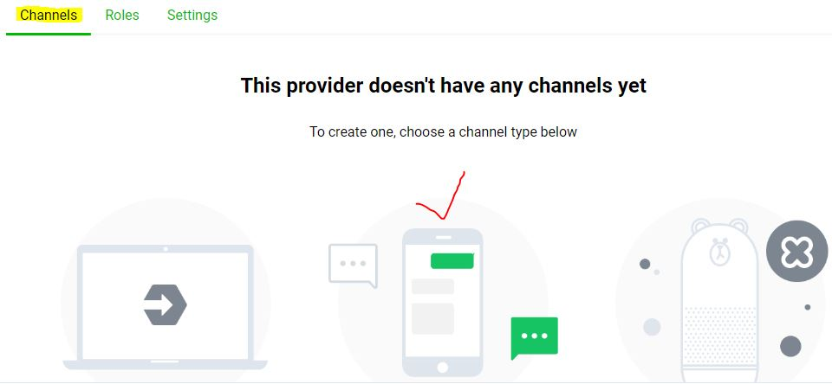

* 1. select Messageing API

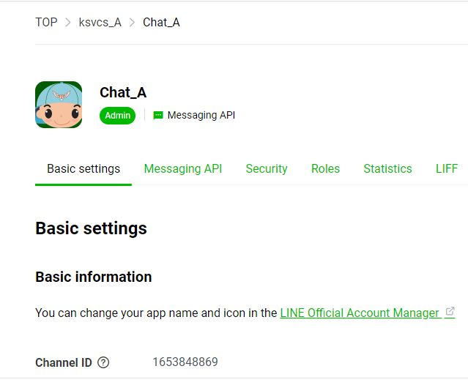

* 1. Basic setting->Secret Key

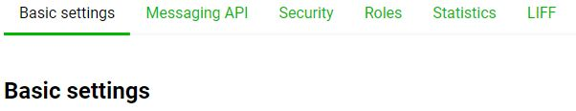

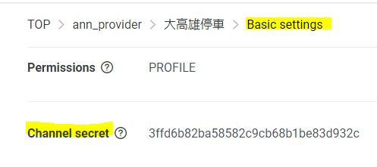

* 1. Messaging API->Line掃描 QR Code

1. Line Bot 管理
   1. Basic_Settings->[LINE Official Account Manager](https://manager.line.biz/account/@364fqgxo/setting)
2. 程式編輯
   1. 安裝 pip install -U line-bot-sdk
   2. 執行ngrok http 5000  
      copy <https://d6f677bd.ngrok.io/callback>

C:\Users\ASUS\AppData\Local\Programs\Python\Python37

C:\Users\ASUS\AppData\Local\Programs\Python\Python37\Scripts

1. Line Bot 的伺服器->Heroku